The analysis includes data from 3/1/2021-1/24/2022. Value reflects the likelihood that for two counties with different levels, the county with the higher severity has the most severe outcome 3 weeks later. 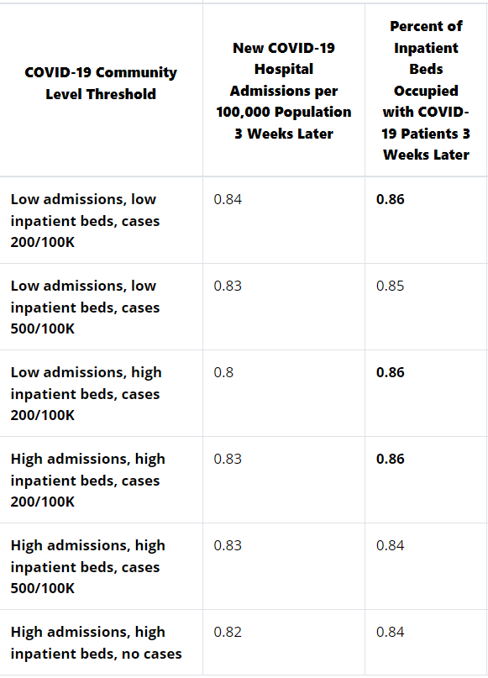New

COVID-19 Hospital Admissions per 100,000 Population 3 Weeks Later

Average Threshold

Date: 2022-02-24

roc.default(response = predict_data$predict_severe_outcome, predictor = predict_data$actual_severe_hospital_admission, percent = TRUE, plot = TRUE, legacy.axes = TRUE, col = "#377eb8", lwd = 4, print.auc = TRUE)

Data: predict_data$actual_severe_hospital_admission in 3361166 controls (predict_data$predict_severe_outcome 0) < 3378216 cases (predict_data$predict_severe_outcome 1).

The area under the curve: 65.71%

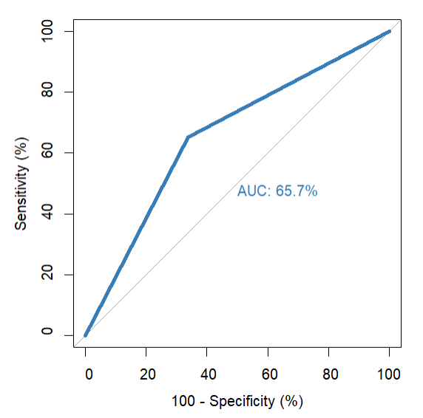

Percent of Inpatient Beds Occupied with COVID-19 Patients 3 Weeks Later

Average Threshold

Date: 2022-02-24 compare to 3 Weeks Later

roc.default(response = predict_data$predict_severe_outcome, predictor = predict_data$actual_severe_inpatient_bed, percent = TRUE, plot = TRUE, legacy.axes = TRUE, col = "#4daf4a", lwd = 4, print.auc = TRUE)

Data: predict_data$actual_severe_inpatient_bed in 3353756 controls (predict_data$predict_severe_outcome 0) < 3370740 cases (predict_data$predict_severe_outcome 1).

The area under the curve: 62.45%

